

Australian Chamber of Commerce and
Industry

Submission to the Packaging
Impacts CRIS

30 March 2012

EXECUTIVE SUMMARY
The Australian Chamber of Commerce and Industry (ACCI) welcomes the opportunity to provide a response to the findings of the Packaging Impacts Consultation Regulatory Impact Statement (CRIS). Non regulatory Option 1 performs strongly compared to the majority of regulatory options. Option 2A, which represents the current Australian Packaging Covenant (APC) under the Product Stewardship Act 2011 was the only option considered to show a positive NPV and BCR greater than 1. Compared to option 1 however, it will only produce a $3.8 million gain per annum. This small benefit does not justify regulatory intervention considering the high level of uncertainty in the projections over the assessment period. ACCI maintains that ministers should use this as an opportunity to choose the least distorting and least interventionist approach.

Introduction
ACCI is the peak council for Australian business associations, and through its membership includes members from all stages of the packaging supply chain – manufacturers, retailers, brand owners and reprocessors.
ACCI recognises the importance of minimising the environmental impacts of packaging. Resource recovery optimisation should be pursued in approaches that reduce regulatory complexity, are cost effective and promote certainty in the business environment.

ACCI Regulatory Reform Policy
Sustainability in environmental policy requires that there is certainty within the business operating environment.
It is appropriate that the principles of best practice regulation be applied to the findings of the Packaging Impacts Consultation Regulatory Impact Statement (CRIS). From the outset ACCI considers that regulation should be developed to address an issue only once all other avenues have been exhausted and shown to be ineffective.
If regulation is considered the most appropriate method of achieving environmental outcomes, the impacts on the business sector need to be taken into account when considering new regulation and should drive efforts to reduce the unnecessary impacts of current regulation. For this reason ACCI takes a net benefit approach to new and existing regulation. ACCI advocates a shift from a detailed and prescriptive “input-based” approach to a broader “output-oriented” approach. Businesses should be given flexibility in meeting the aims of regulations rather than simply having to meet set obligations.

The Findings of the Packaging Impacts CRIS
The non-regulatory Option 1 came in second according to the NPV and BCR as calculated in the Cost Benefit Analysis (CBA). It outperformed the majority of co-regulatory and mandatory options considered, with the exception of Option 2A (and the base case). Option 2A is the current Australian Packaging Covenant (APC) transitioned under the Product Stewardship Act 2011. It was the only option considered that showed a positive Net Present Value (NPV) and Benefit Cost Ration (BCR) greater than 1. Graph 1 below shows the NPV data from Table E.1 adjusted to show the perrformance of each of the options against Option 1 over the 25 year assessment period.

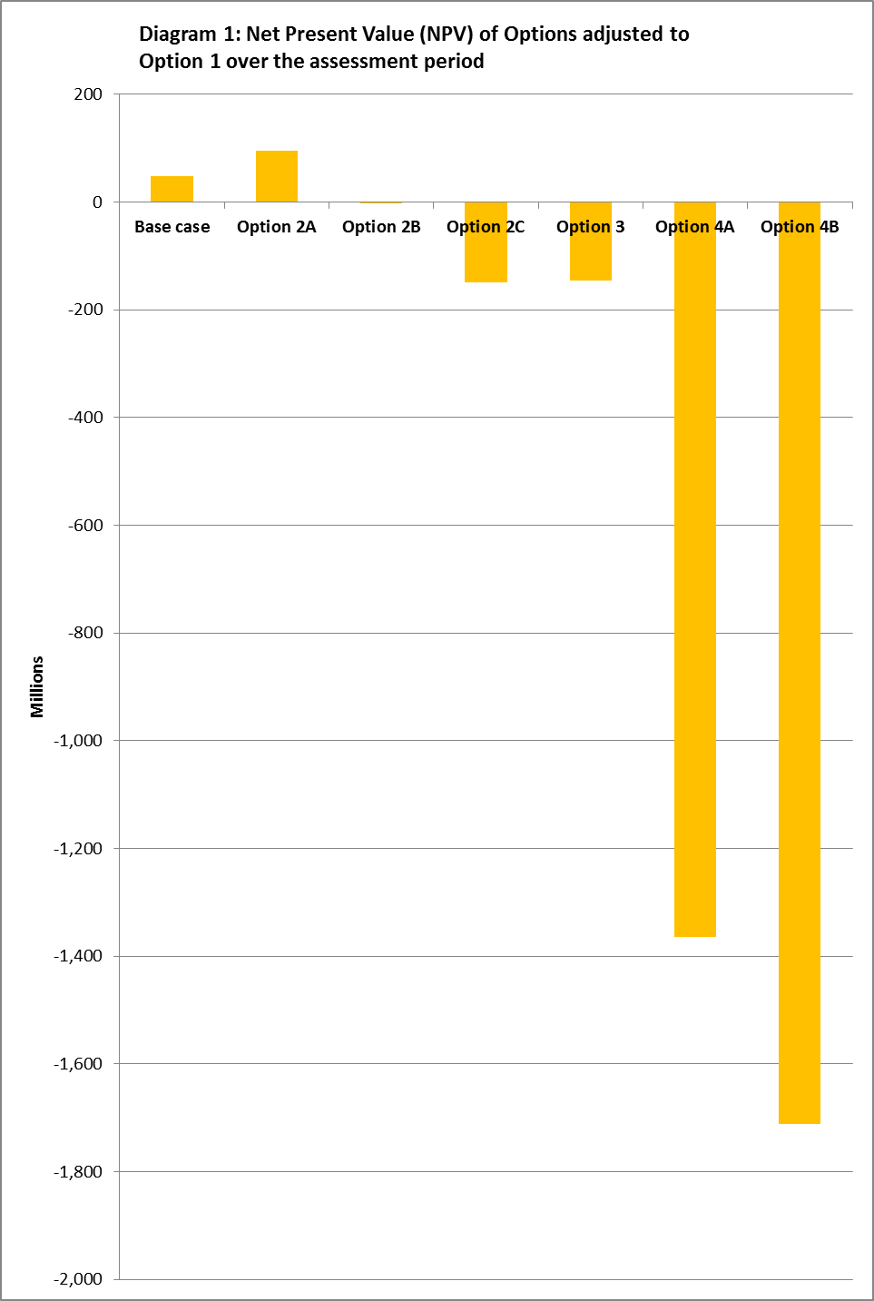
When Option 2A is compared with Option 1, it shows a $95 million benefit over 25 years. This equates to a minimal $3.8 million per annum. Similarly the base case, which shows a $49 million benefit over Option 1, would equate to less than $2 million benefit per annum.
Option 1 is a better performer than Option 2A when the three outcomes of recycling, litter and landfill tonnages are compared. Table E.1 shows that in 2035 Option 1 results in an extra 22 000 tonnes of recycling, 1 000t less litter and 21 000t less packaging waste going to landfill.
Projections for each option are calculated over a 25 year assessment period. Forecasting over such time creates a high level of uncertainty whether each option will actually reach the projected outcomes. Costs should not be imposed on businesses unless there is some certainty that the outcomes will be deliverable. For instance, market values for recyclate are dependent on global commodity prices which are highly variable. Imposing regulated targets on industry to deliver without appreciating these fluctuations could lead to devastating outcomes for businesses. If the value of recyclate decreases, recycling rates would also decrease, increasing compliance costs for liable parties under the regulation. The small benefits gained by Option 2A and the base case per annum do not justify the potential costs to businesses in carrying out these options. Option 1 allows for the greatest level of flexibility to adapt to changes in the operating environment.
The comparatively strong performance of Option 1, in addition to the level of uncertainty in projections over a 25 year period, indicates that regulatory intervention in this area is not justified. ACCI maintains that ministers should use this as an opportunity to purse the least regulatory and most effective approach.

MONTH 2012

ABN 85 008 391 795

Canberra Office
COMMERCE HOUSE
Level 3, 24 Brisbane Avenue
Barton ACT 2600

PO BOX 6005 Kingston,
ACT 2604 AUSTRALIA

T: 02 6273 2311
F: 02 6273 3286
E: info@acci.asn.au

Melbourne Office
Level 3, 486 Albert Street
East Melbourne VIC 3002

PO BOX 18008
Collins Street East
Melbourne VIC 8003
AUSTRALIA

T: 03 9668 9950
F: 03 9668 9958
E: melb@acci.asn.au

W: www.acci.asn.au

© Australian Chamber of Commerce and Industry 2012

This work is copyright. Reproduction is permitted, with direct attribution and notification to the
Australian Chamber of Commerce and Industry.

ACCI MEMBERS

Chambers of commerce & industry

ACT AND REGION CHAMBER OF COMMERCE & INDUSTRY  12A THESIGER COURT  DEAKIN ACT 2600  T: 02 6283 5200  F: 02 6282 2436  E: chamber@actchamber.com.au  www.actchamber.com.au | CHAMBER OF COMMERCE & INDUSTRY QUEENSLAND  INDUSTRY HOUSE  375 WICKHAM TERRACE  BRISBANE QLD 4000  T: 07 3842 2244  F: 07 3832 3195  E: info@cciq.com.au  www.cciq.com.au | NEW SOUTH WALES BUSINESS CHAMBER  LEVEL 15, 140 ARTHUR STREET  NORTH SYDNEY NSW 2060  T: 132696  F: 1300 655 277  E: navigation@nswbc.com.au  www.nswbc.com.au
AUSTRALIAN FEDERATION OF EMPLOYERS & INDUSTRIES  Level 2, 97-99 Bathurst Street  Sydney NSW 2000  T: 02 9264 2000  F: 02 9264 5699  www.afei.org.au | CHAMBER OF COMMERCE & INDUSTRY WESTERN AUSTRALIA  180 HAY STREET  EAST PERTH WA 6004  T: 08 9365 7555  F: 08 9365 7550  E: info@cciwa.com  www.cciwa.com | TASMANIAN CHAMBER OF COMMERCE & INDUSTRY  30 BURNETT STREET  NORTH HOBART TAS 7000  T: 03 6236 3600  F: 03 6231 1278  E: admin@tcci.com.au  www.tcci.com.au
BUSINESS SA  ENTERPRISE HOUSE  136 GREENHILL ROAD  UNLEY SA 5061  T: 08 8300 0000  F: 08 8300 0001  E: enquiries@business-sa.com  www.business-sa.com | CHAMBER OF COMMERCE NORTHERN TERRITORY  CONFEDERATION HOUSE  SUITE 1, 2 SHEPHERD STREET  DARWIN NT 0800  T: 08 8982 8100  F: 08 8981 1405  E: darwin@chambernt.com.au  www.chambernt.com.au | VICTORIAN EMPLOYERS’ CHAMBER OF  COMMERCE & INDUSTRY  486 ALBERT STREET  EAST MELBOURNE VIC 3002  T: 03 8662 5333  F: 03 8662 5462  E: vecci@vecci.org.au  www.vecci.org.au

national industry associations

ACCORD  FUSION BUILDING SUITE 4.02,  LEVEL 4,  22-36 MOUNTAIN STREET  ULTIMO NSW 2007  T: 02 9281 2322  F: 02 9281 0366  E: emifsud@accord.asn.au  www.accord.asn.au | AUSTRALIAN FOOD & GROCERY COUNCIL ASSOCIATION  LEVEL 2, SALVATION ARMY BUILDING  2-4 BRISBANE AVENUE  BARTON ACT 2600  T: 02 6273 1466  F: 02 6273 1477  E: info@afgc.org.au  www.afgc.org.au | AUSTRALIAN PAINT MANUFACTURERS’ FEDERATION  Suite 604, Level 6  51 Rawson Street  EPPING NSW 2121  T: 02 9876 1411  F: 02 9876 1433  E: office@apmf.asn.au  www.apmf.asn.au
AGRIBUSINESS EMPLOYERS’ FEDERATION  250 FOREST ROAD  LARA VIC 3215  T: 03 5272 9223  F: 03 5274 2084  E: aef@aef.net.au  www.aef.net.au | AUSTRALIAN HOTELS ASSOCIATION  LEVEL 4, COMMERCE HOUSE  24 BRISBANE AVENUE  BARTON ACT 2600  T: 02 6273 4007  F: 02 6273 4011  E: aha@aha.org.au  www.aha.org.au | AUSTRALIAN RETAILERS’ ASSOCIATION  LEVEL 10, 136 EXHIBITION STREET  MELBOURNE VIC 3000  T: 1300 368 041  F: 03 8660 3399  E: info@retail.org.au  www.retail.org.au
AIR CONDITIONING & MECHANICAL CONTRACTORS’ ASSOCIATION  30 CROMWELL STREET  BURWOOD VIC 3125  T: 03 8831 2800  F: 03 9888 8459  E: natamca@amca.com.au  www.amca.com.au | AUSTRALIAN INTERNATIONAL AIRLINES OPERATIONS GROUP  C/- QANTAS AIRWAYS QANTAS CENTRE  QCA4, 203 COWARD STREET  MASCOT NSW 2020 | BUS INDUSTRY CONFEDERATION  LEVEL 2, 14-16 BRISBANE AVENUE  BARTON ACT 2600  T: 02 6247 5990  F: 02 6230 6898  E: enquiries@bic.asn.au  www.bic.asn.au
AUSTRALIAN BEVERAGES COUNCIL  LEVEL 1, SUITE 4  6-8 CREWE PLACE  ROSEBERRY NSW 2018  T: 02 9662 2844  F: 02 9662 2899  E: info@australianbeverages.org  www.australianbeverages.org | AUSTRALIAN MADE, AUSTRALIAN GROWN CAMPAIGN  SUITE 105, 161 PARK STREET  SOUTH MELBOURNE VIC 3205  T: 03 9686 1500  F: 03 9686 1600  E:ausmade@australianmade.com.au  www.australianmade.com.au | CONSULT AUSTRALIA  LEVEL 6, 50 CLARENCE STREET  SYDNEY NSW 2000  T: 02 9922 4711  F: 02 9957 2484  E: info@consultaustralia.com.au  www.consultaustralia.com.au
AUSTRALIAN DENTAL INDUSTRY ASSOCIATION  LEVEL 5, 757 ELIZABETH STREET  ZETLAND NSW 2017  T: 02 9319 5631  F: 02 9319 5381  E: national.office@adia.org.au  www.adia.org.au  LIVE PERFORMANCE AUSTRALIA  LEVEL 1  15-17 QUEEN STREET  MELBOURNE VIC 3000  T: 03 9614 1111  F: 03 9614 1166  E: info@liveperformance.com.au  www.liveperformance.com.au | AUSTRALIAN MINES & METALS ASSOCIATION  LEVEL 10, 607 BOURKE STREET  MELBOURNE VIC 3000  T: 03 9614 4777  F: 03 9614 3970  E: vicamma@amma.org.au  www.amma.org.au  NATIONAL FIRE INDUSTRY ASSOCIATION  PO BOX 2466  WERRIBEE NSW 3030  T: 03 9865 8611  F: 03 9865 8615  E: info@nfia.com.au  www.nfia.com.au | HOUSING INDUSTRY ASSOCIATION  79 CONSTITUTION AVENUE,  CAMPBELL ACT 2612  T: 02 6245 1300  F: 02 6257 5658  E: enquiry@hia.com.au  www.hia.com.au  PRINTING INDUSTRIES  ASSOCIATION OF  AUSTRALIA  25 SOUTH PARADE  AUBURN NSW 2144  T: 02 8789 7300  F: 02 8789 7387  E: info@printnet.com.au  www.printnet.com.au
MASTER BUILDERS AUSTRALIA LTD  LEVEL 1, 16 BENTHAM STREET  YARRALUMLA ACT 2600  T: 02 6202 8888  F: 02 6202 8877  E: enquiries@masterbuilders.com.au  www.masterbuilders.com.au | NATIONAL RETAIL ASSOCIATION  PO Box 1544  COORPAROO DC QLD 4006  T: 07 3240 0100  F: 07 3240 0130  E: info@nra.net.au  www.nra.net.au | RESTAURANT & CATERING AUSTRALIA  SUITE 17, 401 PACIFIC HIGHWAY  ARTARMON NSW 2064  T: 1300 722 878  F: 1300 722 396  E: restncat@restaurantcater.asn.au  www.restaurantcater.asn.au
MASTER PLUMBERS’ & MECHANICAL SERVICES ASSOCIATION OF AUSTRALIA (THE)  525 KING STREET  WEST MELBOURNE VIC 3003  T: 03 9329 9622  F: 03 9329 5060  E: info@mpmsaa.org.au  www.plumber.com.au | OIL INDUSTRY INDUSTRIAL ASSOCIATION  C/- SHELL AUSTRALIA  GPO BOX 872K  MELBOURNE VIC 3001  F: 03 9666 5008 | VICTORIAN AUTOMOBILE CHAMBER OF COMMERCE  LEVEL 7, 464 ST KILDA ROAD  MELBOURNE VIC 3004  T: 03 9829 1111  F: 03 9820 3401  E: vacc@vacc.asn.au  www.vacc.com.au
NATIONAL BAKING INDUSTRY ASSOCIATION  BREAD HOUSE  49 GREGORY TERRACE  SPRING HILL QLD 4000  T: 07 3831 5961  E: nbia@nbia.org.au  www.nbia.org.au | PHARMACY GUILD OF AUSTRALIA  LEVEL 2, 15 NATIONAL CIRCUIRT  BARTON ACT 2600  T: 02 6270 1888  F: 02 6270 1800  E: guild.nat@guild.org.au  www.guild.org.au
NATIONAL ELECTRICAL & COMMUNICATIONS  ASSOCIATION  LEVEL 4, 30 ATCHISON STREET  ST LEONARDS NSW 2065  T: 02 9439 8523  F: 02 9439 8525  E: necanat@neca.asn.au  www.neca.asn.au | PLASTICS & CHEMICALS INDUSTRIES ASSOCIATION  LEVEL 10, 10 QUEEN STREET  MELBOURNE VIC 3000  T: 03 9611 5412  F: 03 9611 5499  E: info@pacia.org.au  www.pacia.org.au

