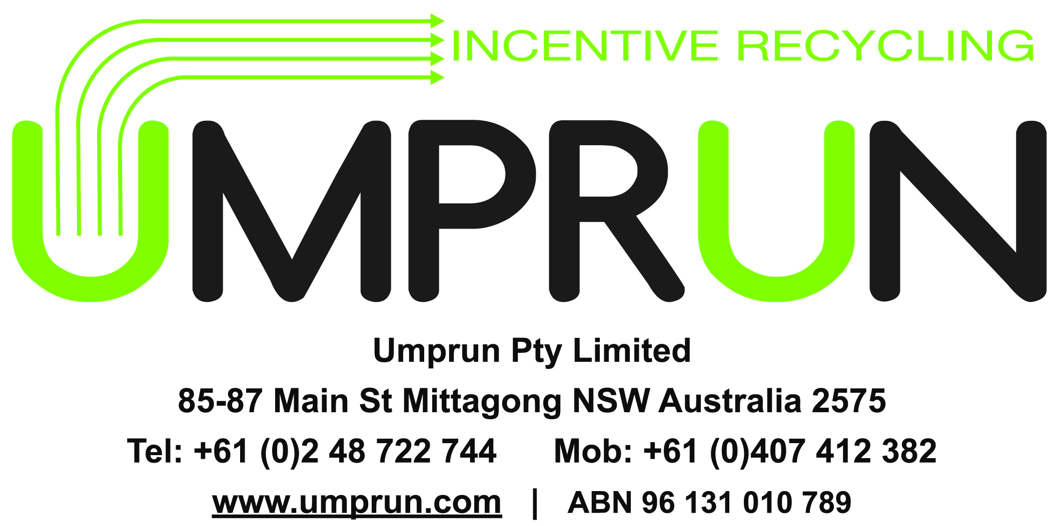

29 March 2012

SECW Secretariat,

Standing Council on Environment and Water Secretariat,

GPO Box 787,

CANBERRA ACT 2601.

Dear Madam or Sir,

Please find attached to this letter four documents which make up Umprun Pty Ltd’s written response to the Packaging Impacts Consultation RIS.

This response probably falls outside commenting ‘on a limited number of measures that have the potential to increase packaging resource recovery rates and decrease packaging litter, addressing Strategy 3 of the National Waste Policy. The measures that ministers agreed to consider included a national CDS, advance disposal fee, and workplace, events, hospitality and institutions recovery.’

This response is a genuine and honest attempt to explain why the current waste system is flawed and that additional measures need to be considered than the ones suggested by the ministers.

UPL’s concept is to release the inherent dollar$ value associated with domestic used packaging material in the home utilising a domestic recycling appliance called a Recyclertron™ and deliver a fair share of the released dollar$ value back to the householder – they who ‘actually’ do the recycling. The UPL definition of ‘recycling’ in the domestic context is the collection, separation and processing of used food and beverage containers to products with exact technical specifications to match existing markets.

UPL’s goal is to provide a way via the operation of Recyclertron™s for the millions (and probably billions by now) of householders who really ***want*** to ‘actually’ recycle their packaging and also guarantee that they deliver a resource recovery benefit to their environment and planet. In return for householders’ investing in another household appliance and performing the actual recycling effort, Recyclertron™s will reward them with both time-saving convenience benefits and cash payments.

This is a financially self-sustaining dollar$ value and market driven system which will ‘increase packaging resource recovery rates and decrease packaging litter, addressing Strategy 3 of the National Waste Policy’ at no cost to any ministers, councillors or government budgets and therefore warrants serious consideration by the minsters as a worthwhile measure.

Yours faithfully,

Aldous Hicks

**Response to Packaging Impacts Consultation RIS**

**Summary**

The meaning of the word ‘waste’ as defined in the dictionary is “something of no value”.

Once this definition is accepted and used the solution to achieving near 100% resource recovery in the domestic, commercial or industrial sectors needs to simply recognise:

1. waste at the kerbside, commercial or industrial pick-up site is NOT waste it is **used-material**
2. **used-material** has a dollar$ value
3. at the site where it is created, the **used-material** can be processed to produce beautiful high dollar$ value products
4. the dollar$ value of these beautiful products will ‘***drive’*** used-material resource recovery to levels approaching 100%
5. the ‘***driver’*** is the normal and well known self-sustaining market forces.

Please note for the remainder of this response the words ***‘used-material’*** will be used in place of the incorrect word ***‘waste’***.

Once the valuable used-material is ear-marked or destined for the current waste system (domestic or commercial or industrial) the used-material is immediately transformed to ***‘worse-than-waste’*** (if that is possible) because it does not have zero or waste value any more – it takes a serious hit and takes on a significant cost or negative dollar$ value. Sadly and in spite of brilliant technology and system developments over twenty plus years the current waste system cannot and will never generate enough dollar$ value to overcome the cost hit.

The current ***waste*** systems anywhere in the world (Europe included) are structurally flawed because their aims (or Holy Grail) are to maximise high volume through-put of ***‘worse-than-waste’*** through their systems. The high-volume systems despite 20 years of technical and commercial development (resulting in brilliant technology) have not delivered (and never will) sufficient recycled product value to overcome the huge starting financial hurdle of commencing their waste systems with ‘***worse-than-waste’.*** Maximising high volume through-put of ***‘worse-than-waste’*** rather than maximising the dollar$ value of the used-material where it was created is the basic flaw of the current waste systems. The flaw can be simply, easily, quickly and very cheaply corrected – and all by market forces and at no cost to Federal, State or Local governments.

In contrast to picking up ‘worst-than-waste’ the used-material at the kerbside (or commercial or industrial) site can be processed to gain significant dollar$ value. It can become beautiful, pure and valuable market ready products with real dollar$ values. For example, there is no reason why glass cullet at the kerbside could not have a value higher than A$40 per tonne. PET & HDPE could have a value between $300 and $1,700 per tonne at the kerbside and so on. Compare a ***‘worse-than-waste’*** cost per tonne at the kerbside to the very lowest $40+ or $300-$1,700 per tonne. Starting at the kerbside with products with these dollar$ values will drive and incentivise a 100% market-driven solution where resource recovery levels will approach 100%.

The beautiful pure and high-value products are created at the kerbside by utilising human intelligence in association with a Recyclertron™ - a domestic recycling appliance. UMPRUN (**u**sed-**m**aterial **pr**ocessing **un**it) is the generic name for the used-material processing equipment or appliance that will exist at sites (domestic, commercial or industrial) where used-material is generated.

Recyclertron™s or UMPRUNs aim (or Holy Grail) is to maximise the dollar$ value of the used-material ***at the site*** where the used-material is created. After processing through a Recyclertron™ or UMPRUN the used-materials become beautiful high dollar$ value products which are specification-ready for the sale into existing strong and vibrant product markets. No new highly risky and expensive markets need to be developed like the attempts of developing cullet for road base for example.

A Recyclertron™ is a domestic appliance – just like a refrigerator or dishwasher or washing machine or dryer etc. And just like it is with all other domestic appliances, households will purchase a Recyclertron™. Households buy refrigerator or dishwasher or washing machine or dryer etc because they deliver convenience value and benefits. Householders will also buy Recyclertron™s because they deliver convenience value and benefits. However additionally and uniquely your Recyclertron™ will actually earn you money because you will be paid for the beautiful high dollar$ market-ready products you produce.

Each and every Recyclertron™ appliance in a household will be a beautiful ***green-machine!*** Why a ***green-machine?*** Clearly all domestic appliances like refrigerators or dishwashers or washing machines or dryers etc have Life Cycle Assessment energy, carbon dioxide equivalent emissions (CO2e) and material costs. These costs result from the materials, manufacturing, the logistics associated with the appliance finding its way into a household, the electrical power and other running costs and then finally the disposal of the appliance at the end of its useful life. All Recyclertron™ appliances in households the world-over will deliver profitable Life Cycle Assessments (LCA). While Recyclertron™s have all the same LCA costs as every other domestic appliance, uniquely (and a world first) the net LCA value (energy, CO2e and material) delivered by the beautiful high dollar$ value products produces a POSITIVE(+) outcome! Yes – positive LCA is correct. So yes - Recyclertron™s are justifiably beautiful ***green-machines!***

For more information about UMPRUNs and the justifiably beautiful ***green-machine*** Recyclertron™ please go to [www.umprun.com](http://www.umprun.com)

**Comments to Packaging Impacts Consultation RIS**

To EXECUTIVE SUMMARY – The Problems - Page xi

“The key problem with the current state of packaging consumption and recycling in Australia is that Government objectives for reduced waste and increased resource recovery are not being met **due to the low or suboptimal rates of recycling** for glass, plastic, steel and aluminium in the **commercial, hospitality and institutional sectors (away-from-home)**.”

**RESPONSE:** Even if the domestic recycling % levels, which are stated in the report, are correct (which I seriously question) surely the Australian society does not accept that of short fall of 30% (assume recycling level of 70%) is satisfactory.

**SOLUTION:** ***Set aspirational goals of 100% and look to sensible and practical market and individual driven solutions to deliver the 100% goal, vis UMPRUNs and Recyclertron™s.***

Another issue is that innovations in packaging design are not necessarily improving the recyclability of packaging materials.

**RESPONSE:** As long as the current waste systems delivers NO market signals and especially NO price signals to those purchasing the containers then surely sensibly and logically there can be zero expectation that packaging manufacturers will improve the “the recyclability of packaging materials.”

**SOLUTION: *UMPRUNs and Recyclertron™s will deliver the market signals and especially price signals via householders obtaining a greater sale price for recycled containers which have improved recyclability.***

In addition, there is a potential for increasingly fragmented jurisdictional approaches which add to regulatory complexity, increase business costs and uncertainty for investment, and fragment end-markets. The resultant inconsistency and duplication hinder the efficient operation of businesses operating in a national market.

**RESPONSE:** No jurisdictions, regulatory complexity, increase business costs and uncertainty for investment, and fragment end-markets are required.

**SOLUTION: *Let UMPRUNs and Recyclertron™s achieve the result with zero jurisdictions etc where the process will be 100% market driven and 100% delivered and operated by private industry and households.***

Continued improvements in recycling rates will rely on local government who provide municipal services. The current disparity in provision of services across urban, regional and rural settings illustrates that an expansion and improvement of these services cannot be assumed.

**RESPONSE:** No local government input is required. No local government services required and therefore no disparity.

**SOLUTION: *UMPRUNs and Recyclertron™s purchased and operated by households, businesses or organisations with pick-up services provided by private existing industry will deliver improvements in recycling rates with no reliance on local government.***

To EXECUTIVE SUMMARY – OBJECTIVES – Page xi

The objectives of government action are to:

* reduce packaging waste and increase packaging resource recovery
* reduce the need to landfill recyclable packaging materials
* reduce the negative amenity, health and environmental impacts of packaging waste and litter in line with community expectations, and
* promote a consistent national approach to regulating packaging.

**RESPONSE:** All objectives delivered will be by UMPRUNs and Recyclertron™s and at no cost to Federal, State or Local governments.

**SOLUTION: *UMPRUNs and Recyclertron™s purchased and operated by households, businesses or organisations with pick-up services provided by private existing industry will deliver all the objectives.***

To EXECUTIVE SUMMARY – OPTIONS TO ADDRESS THE PROBLEMS – Page xi

Options considered in this Consultation RIS are:

Option 1: National Waste Packaging Strategy

Option 2: Co-regulatory Packaging Stewardship, with three specific sub-options

* 2 (a): the Australian Packaging Covenant replaced by co-regulation under the *Product Stewardship Act 2011*
* 2 (b): Industry Packaging Stewardship
* 2 (c): Extended Packaging Stewardship

Option 3: Mandatory Advance Disposal Fee

Option 4: Mandatory Container Deposit Scheme (CDS), with two specific sub-options

* 4 (a): Boomerang Alliance CDS
* 4 (b): Hybrid CDS

**RESPONSE:** All of these Options:

1. assume the business as usual (BAU) case of maximising high volume throughput of ***‘worse-than-waste’*** through the current waste systems.
2. will guarantee “fragmented jurisdictional approaches which add to regulatory complexity, increase business costs and uncertainty for investment, and fragment end-markets. The resultant inconsistency and duplication hinder the efficient operation of businesses operating in a national market.”
3. will rely “on local government who provide municipal services” and we all know Local Governments are strapped for cash so they cannot assist more than they do already with the implementation of these options

and therefore all four of the options will not enhance the situation until the BAU current waste system is changed.

The two Option 4s will enhance the collection levels of recyclable food and beverage containers included in the CDS. However, CDSs overall performance is only as good as the weakest link in the chain and that is the current waste system’s capability to actually recycle the increased collection levels. As such, the actual recycling levels are much the same for both CDS and kerbside recycling systems.

**SOLUTION: *Look to UMPRUNs and Recyclertron™s purchased and operated by households, businesses or organisations with pick-up services provided by private existing industry to deliver a value driven self-sustaining use-material system.***

***Recyclertron™s together with CDS deliver a fantastic outcome including the highest collection levels and because Recyclertron™s can be designed to verify the container and thereby claim the deposit back the householders receive a much greater financial incentive to purchase Recyclertron™s thereby delivering greater levels of the highly valuable closed-loop recycled products.***

To BACK GROUND AND CONTEXT – 2.3 End-of-Life Packaging Recovery – Page 6

In 2010, 62.5 per cent of packaging was recycled.

**RESPONSE:** Let’s firstly just assume the tonnage figures are correct. Then Yes 62.5% of packaging by weight was recycled. But if we use a dollar$ value of the possible recycled materials in place of a tonnage figure then in 2010 ONLY 44.9% of packaging was recycled.

If we remove the least valuable recycled material - paper/cardboard - from the packaging recycling percentage figures, then in 2010 the recycling percentage by tonnage is 42% and by value 39%.

So let’s make sure we do the sensible thing in the future and focus on recycling the materials which has the greatest dollar$ value firstly and secondly on those that deliver the best environmental outcome. The current waste system to date has delivered an upside down outcome or in Ozzie vernacular an ‘a…-about’ outcome.

**SOLUTION: *Rather than perpetuate the current failed waste system look to a used-material system solution that focuses on enhanced product dollar$ value rather than tonnage. Such a household system is a Recyclertron™ appliance purchased and operated by households, businesses or organisations.***

Recovery refers to the collection of solid waste that can be sorted and processed for recycling. Recovery and recycling differs between at-home and away-from-home locations.

**RESPONSE:** Is it possible that the figures in Table 2 are “recovery” tonnage figures and not actually recycled tonnage figures. This would explain why the “recycling” figures seem rather high.

**SOLUTION: *Recycling tonnages should be the tonnages of recycled materials that are actually used in other products. For example, while many tonnes of glass bottles are recovered for recycling many less tonnes become cullet due to losses in the current waste systems’ glass container processing. Of the cullet produced less than half is suitable for closed-loop recycling. What happens to the remainder is not clear. A small percentage ends up as road base. Anecdotally most of the remainder ends up in stockpiles before eventually making its way to landfill sites.***

To BACK GROUND AND CONTEXT – 2.3 End-of-Life Packaging Recovery – Page 7

TABLE 2: RECYCLING PERFORMANCE BY CONSUMPTION LOCATION AND MATERIAL TYPE 2009-10

|  |  |  |  |  |
| --- | --- | --- | --- | --- |
| Packaging material | **Consumption**  **(tonnes)** | **At-home recycling (%)** | **Away-from-home recycling (%)** | **Total recycling (%)** |
| Paper/cardboard | 2,680,000 | 75.6 | 75.5 | 75.5 |
| Glass | 991,000 | 53.8 | 26.6 | 47.0 |
| Plastics | 565,285 | 51.7 | 23.1 | 34.8 |
| Steel cans | 136,249 | 37.0 | 14.6 | 30.3 |
| Aluminium | 51,600 | 77.5 | 57.3 | 67.4 |
| Total | 4,424,134 | 60.0 | 64.0 | 62.5 |

**RESPONSE:** These figures must be seriously questioned. For example, Away-from-home recycling percentages are very different for each packaging material except paper/cardboard where the At-home and Away-from-home figures are exactly the same. How can that be?

Glass recycling percentage of 47% is an amazing figure. Between 21% and 25% is the maximum percentage that glass cullet makes up of the current glass remelt furnace batches in Australia and the US. This means that the remaining recycled percentages of between 22% and 26% of the 47% of cullet recycled goes into road base or some other use. I very much doubt this figure and therefore the 47% is extremely doubtful.

The Australian total recycling of all plastics is higher than that achieved for PET (probably the most collected and recycled plastic along with HDPE) in Europe. Please refer to:

**Headline News**

**PET Collection Increases in Europe**

7/19/2011

Two European-based groups report collection of PET plastics nears 50 percent.

Petcore, Brussels, and the European Plastics Recyclers (EuPR) also headquartered in Brussels, have reported that European post-sorting PET collection reached 1.45 million metric tons in 2010, an increase of 6.5 percent from 2009’s collection figures. The increase for the year pushed the overall collection rate in 2010 to 48.3 percent of all PET bottles on the market.

Note clearly in Europe the 2010 overall PET collection rate is 48.3% of the consumption. This is collection ONLY for PET ‘bottles on the market’ – the highest plastic (along with HDPE) collected and the highest plastic recycled (along with HDPE) of all plastics consumed. So if we assume Australia collects the same percentage of PET consumption as in Europe (a very unlikely assumption) and Australia achieves its recycling level 34.8% of all plastics consumed then the effective Australia recycling rate for PET is over 72% of the plastics it collects. It would be a revelation to me if the Australian collects a higher percentage of plastic than Europe and an even greater revelation if Australia’s PET recycling levels are higher than Europe.

So I do not consider the figures in Table 2 to be correct. But that does not matter and it is not the issue. Even if we recycled 62% overall of all hard recyclables including paper/cardboard or 42% of all hard recyclables excluding including paper/cardboard we still have a huge lot of addition recycling to do. And very little of the recycling is actually closed-loop recycling and it is closed-loop recycling that delivers the environmental benefits. For example, using glass cullet as road base does not provide anything like the energy saving that closed-loop recycling glass cullet into glass re-melt furnaces achieves.

Is there any chance that the report’s authors like the majority of the community, think that collection is equivalent to recycling?

It should be noted that both the dollar$ value and environmental value of real-recycling is gained from closed-loop recycling. In other words the used-container collected is then processed so that the recycled product is used to produce the exact same container. For example – cullet from a glass wine bottle becomes a new glass wine bottle. Or used PET containers are recycled to be used as new PET containers. In Europe, from the Petcore and European Plastics Recyclers (EuPR) report, the closed-loop recycling percentage is approximately 12%. In the US, Coca-Cola close-loop recycles less than 4% of its PET containers (direct advice from Coca-Cola Recycling LLC in Atlanta). It is understood that Australia’s closed-loop recycling levels are similar to those achieved in the US.

Additionally is should be noted that the highest consumption of packaging by weight is paper/cardboard representing 60% of the total. However the potential recycle dollar$ value of paper/cardboard as a percentage of the value of all packaging material being recycled is only 17%. If all plastics were recycled, the recycled dollar$ value represents 50% of the total recyclable dollar$ value.

So the current waste system achieves the highest recycling level for the least valuable recyclable material. How does that make sense? Clearly it does not.

**SOLUTION:** ***Let Recyclertron™s deliver the sensible aim of recycling the used-materials which have the greatest dollar$ value not the greatest tonnage.***

To BACK GROUND AND CONTEXT – 2.3 End-of-Life Packaging Recovery – At Home – Pages 7 & 8.

At home, consumers generally sort their general waste from recyclables and this is collected by the kerbside collection service proved by their local government.

**RESPONSE:** With the waste collection industry’s move back to single-stream collection there will be no need for householders to “sort their general waste from recyclables”. Effectively, as many householders correctly suspect, it makes no difference if a householder sorts or not, as the waste and recyclables all end up in the same placer. It is either at a materials recovery facility (MRF or Merf) or in landfill. When this fact becomes common knowledge householders will ask the valid question of why have we been wasting our time sorting recyclables from waste in two or more bins, keeping more than one bulky, dirty and smelly bins, putting out two or more bins and bringing back two or more bins from the kerb. Householders will become aware of the scam that has been put upon them and also the costs they have forked out for no reason.

**SOLUTION: *Let householders buy Recyclertron™s so householders can actually recycle and know exactly how much they recycle. How much will be in a direct relationship with the dollar$ value of the used-materials each household recycles.***

It should also be noted that local government, which has primary responsibility for the collection of materials at home for recycling, is at the end of the supply chain and has limited influence over decisions relating to packaging manufacture and use. Transferring some of the responsibility to manufacturers and users has the potential to promote greater recycling and reduce environmental impacts.

**RESPONSE:** Local government has NO or ZERO ‘influence over decisions relating to packaging manufacture and use.’ However ‘Transferring some of the responsibility to manufacturers and users’ is a form of Extended Producer Responsibility (EPR). Clearly the manufacturers and the users (you and me) obtain value from the packaging. Surely it is our (manufacturers and the users) responsibility to recycle the used-materials. And with UMPRUNs and Recyclertron™s manufacturers can deliver EPR and users can do the recycling themselves.

**SOLUTION: *Assist Recyclertron™s to be developed so manufacturers can provided EPR driven incentives for householders to buy Recyclertron™s and so that when householders buy and operate Recyclertron™s in their homes, householders can take responsibility themselves to recycle their packaging. It is very clear that householders want to recycle.***

To BACK GROUND AND CONTEXT – 2.3 End-of-Life Packaging Recovery - ENVIRONMENTAL BENEFITS OF RESOURCE RECOVERY – Pages 8 & 9

Most new glass contains between 40 per cent and 70 per cent cullet.

**RESPONSE:** There are clear benefits of recycling. The ‘environmental benefits’ of recycling really only come about when used-materials are ***closed-loop*** recycled. Also the claims need to be accurate. I seriously question the statement ‘Most new glass contains between 40 per cent and 70 per cent cullet.’ From my understanding and personal investigations, the main glass manufacturers around the world currently load their remelt furnaces with approximately 25% of the batch being cullet. This information was obtained from OI whose head office is in Perryburys in Ohio, USA where I visited last year. OI is the largest glass bottle manufacturer in the world, My understanding - again from personal contact here in Australia - is that Amcor at Gawler in SA also currently load their glass re-melt furnaces with cullet to the tune of approximately 25%. OI and Amcor could both run their furnace material batches at 90% cullet and obtain a near fourfold increase in closed-loop recycling value which is made up of energy savings and furnace reline savings. Both OI and Amcor cannot obtain the colour purity cullet that their re-melt furnaces require. The current waste system fails the manufacturers and purchasers (you and me) of beautifully-closed-loop-recyclable glass containers because the current waste system cannot deliver glass cullet, and never will, to the required specification. Not one of the OPTIONS TO ADDRESS THE PROBLEMS on Page xi of this RIS will improve the current closed-loop glass recycling situation either now or in the future.

**SOLUTION: *Recyclertron™s will produce colour-pure 100% closed-loop recyclable cullet to glass re-melt furnace specification. Also instead of the very low and market controlled A$40 per tonne that the sale of glass cullet current obtains, there is every reason to suggest that with a 10% penetration of Recyclertron™s into households the cullet sale price could jump to A$80 per tonne and more. This will deliver an even greater financial incentive for householders to close-loop recycle their glass containers. And with a greater incentive, more households will purchase Recyclertron™s and the price of the cullet – on a purely energy saving and glass re-melt furnace reline savings – can justifiable potentially climb to A$120 per tonne. And so it will go on until 100% of glass containers are close-looped recycled.***

To BACK GROUND AND CONTEXT – 2.6 NATIONAL CONTEXT – NATIONAL POLICIES – Page 12

The aims of the National Waste Policy are to:

* avoid the generation of waste; reduce the amount of waste (including hazardous waste) for disposal; manage waste as a resource and ensure that waste treatment, disposal, recovery and reuse is undertaken in a safe, scientific and environmentally sound manner

**RESPONSE:** As previously mention in the Summary at the start of this document using the word ‘waste’ is at the root cause of the low recycling levels achieved across Australia and the world. “Manage waste as a resource” is a very clear contradiction. Hence we need to realise and accept that what is being produced is ‘used-material’ not waste. On the other hand “worse-than-waste” is produced once used-material is earmarked for the current waste system.

**SOLUTION: *Ensure as much as possible of the used-material becomes beautiful high dollar$ value products at the site that the used-material is created. Recyclertron™s purchased and operated by households, businesses or organisations maximises the amount of used-material processed to closed-loop recycled products thereby dramatically enhancing the used-material dollar$ value.***

The following strategies are of particular relevance under this key direction:

Strategy 1: establish a national framework underpinned by legislation to support voluntary, co-regulatory and regulatory product stewardship and extended producer responsibility schemes to provide for the impacts of a product being responsibly managed during and at end of life (EPHC 2009, p. 9).

**RESPONSE:** Product stewardship (PS) or extended product responsibility (EPR) can be delivered without the need for ‘a national framework underpinned by legislation to support’ so long as the use-material, automatically generated at the end-of-product life, is enhanced in dollar$ value at the site the use-material is created. When enhanced dollar$ value products processed to existing market product specifications are purchased, PS and EPR for the products is automatically delivered. On the other hand, if the used-material finds its way into the current waste stream and becomes ***‘worse-than-waste’*** then there is no possibility that PS or EPR can be delivered even in ‘a national framework underpinned by legislation’ for an amount more than the closed-looped recycling levels delivered by the current waste system. Current closed-loop recycling percentage levels vary from the highest with aluminium containers of more than 60% down to plastics below 5%.

**SOLUTION: *Recyclertron™s will deliver 100% of its processed used-material to closed-loop beautiful high dollar$ value recycled products thereby delivering 100% PS and EPR for the products at their end-of-life.***

To BACK GROUND AND CONTEXT – 2.6 NATIONAL CONTEXT – COMMUNITY EXPECTATIONS – Page 13

The community is strongly committed to kerbside recycling.

**RESPONSE:** The community is strongly committed to ‘kerbside recycling’ because mostly they think and believe that the containers they put out at the kerbside in recycle bin will be recycled. The community desperately wants to recycle. Householders have expected that the current waste system will recycle their material that they diligently place in their recycle bin and that they diligently putout down by the kerbside ever week or fortnight. Sadly little do they know! Clearly the common term ‘kerbside recycling’ is a lie. There is no recycling at the kerbside. ‘Kerbside container collection’ is an accurate description and is the truth.

**SOLUTION: *Assist householders to do what they really want to do – actually recycle. Recyclertron™s will allow householders to actually recycle their recyclable containers, while also delivering convenience benefits like other household appliances do and uniquely deliver financial remuneration for the household’s recycling efforts.***

The community is strongly committed to kerbside recycling. In the twelve-month period to March 2009, 95 per cent of households had recycled or reused paper, cardboard or newspapers. Other commonly recycled or reused items included plastic bottles (94 per cent), glass (93 per cent) aluminium cans (84 per cent) and steel cans (80 per cent) (ABS 2009a; ABS 2009b).

**RESPONSE:** Clearly, patently and deliberately the use of the word ‘ … recycled …’ in the text is wrong. That is unless ‘recycling’ can also mean that the newspaper is ‘recycled’ to say light the fire, or glass containers are washed and ‘reused’ for storing say the home-made salad dressing. The intended meaning of the word ‘recycling’ or ‘recycled’ in the text above in every case is a fraud. Recycling in the context above refers to the action of a householder in placing a recyclable used container in a separate bin from the waste bin. But this action is clearly and definitely not ‘recycling’. Even the common term ‘kerbside recycling’ is a lie. There is no recycling at the kerbside. ‘Kerbside container collection’ is accurate and is the truth.

**SOLUTION: *Have the guts to fess-up and admit the lies and fraud perpetuated by the incorrect usage of the term ‘recycling’ as exampled in the text above and start telling householders the truth.***

To Deliver the Circular Economy and Packaging EPR

**Executive Summary**

The Circular Economy is a benchmark for the future and highlights the Economic and Waste Management Cycles – see Diagram 1 page 2. The concept is to treat waste as a resource. Today’s waste management cycle, which is based on the concept of highest-volume material throughput at the least cost, does not yet deliver the Circular Economy and it is questioned that it ever can without significant changes.

This concept is called into question because the 20 year plus report card demonstrates a recycling level of 50-60%. And closed-loop recycling levels, must-haves for a successful Circular Economy, are at significantly lower levels. The waste generation activity, the starting point of the current waste management system, immediately destroys much of the material value and thereby any chance of delivering packaging EPR. Further the resultant low-quality low-value recycled materials currently delivered still require the development of large new markets or substantial material substitution of well-established high-volume low-price highly competitive markets. Either way, both marketing strategies are expensive and risky to implement. The investment to date to obtain this work-in-progress has been in the hundreds of billions of dollars. Has the progress justified the expenditure? How many more billions of dollars will needed on developing an apparently questionable future outcome?

An alternative “used-material” cycle is suggested which sets purity of product as the primary over-arching goal. It requires a used-material capture point earlier in the used-material disposal chain and a machine (not human) decision guaranteeing that only the exact same materials are separately processed, stored and delivered. From this start, the concept suggests a new recycling appliance for a domestic application and a new piece of equipment for commercial and industrial applications. **Recyclertron©** is the household appliance and UMPRUN - an acronym for **U**sed **M**aterial **PR**ocessing **UN**it - is the generic name for the commercial and industrial (C&I) and construction and demolition (C&D) industry applications.

For **Recyclertron©s** to deliver the Circular Economy they must be purchased by large numbers of householders raising the question – “Why would a householder spend their hard earned cash on a **Recyclertron©?”**. In a benefits comparison with refrigerators, which have over 99% market penetration into western households, **Recyclertron©s** stack up well. The Used-Material Management Cycle with UMPRUNs and **Recyclertron©s** generates financial value and therefore it is included in the Economic Cycle of the Circular Economy model rather than in the value destroying current Waste Management Cycle.

The Used-Material Management Cycle with UMPRUNs and **Recyclertron©s** will require human behavior to change, which is not always a simple and easy task. In households **Recyclertron©s** will provide convenience benefits and financial incentives to persuade human behavioral change. Operating a **Recyclertron©** will environmentally be equivalent to growing trees! In addition, individuals will know their own exact environmental contribution to the social good creating a “feel good” and “feel responsible” emotion. These are much stronger human motivators and persuaders than the current waste industry methods of information provision requesting voluntary action of consumers to produce ever more questionable outcomes.

An important consequence of the Used-Material Management Cycle with **Recyclertron©s** is that producers (brand owners) and retailers now have a realistic path to regain and deliver packaging EPR.

To implement the Used-Material Management Cycle commercially-ready **Recyclertron©s** must be available as soon as possible for households to purchase. The commercialization of a **Recyclertron©** needs existing waste industry equipment and processes, eg. wash cycles, material identification sensors, grinders, granulators and compactors, to be made simpler, lighter, smaller and cheaper and suitable for mass manufacturing of the components. Re-engineering will be performed in the first commercialization stage and be the commencement of a parallel commercialization of custom UMPRUNs for C&I and C&D industry applications.

Successful commercialization of **Recyclertron©s** and UMPRUNs will deliver the Circular Economy and packaging EPR at a rate commensurate with the market penetration achieved. The market penetration will be self-funded by consumers, factory owners, producers (brand owners), retailers, other businesses and organizations who have already gained the benefits from the use of the material they no longer use, need or want. And isn’t that the way it should be?

The same consumers, factory owners, producers (brand owners), retailers, other businesses and organizations by purchasing and operating **Recyclertron©s** and UMPRUNs will be the beneficiaries of the value creating Used-Material Management System. Even more important beneficiaries will be the planet and future generations.

Commercialization funds are needed now by Umprun Pty Limited to start and complete the **Recyclertron©/**UMPRUN commercialization project.

**The Circular Economic Model - For the Near Future**

The Circular Economy highlights the Economic and Waste Management Cycles - see Diagram 1. The concept of the Circular Economy is to treat waste as a resource, and thereby to change the way in which the waste management industry is seen.

In the SITA UK report titled “ACHIEVING THE VISION OF NO MORE WASTE – Engaging in the Circular Economy” the concept is described in more detail. The report is authored by Dr Gev Eduljee, External Affairs Director at SITA UK and Umprun Pty Limited (UPL) gives thanks to Dr Eduljee and SITA UK for permission to use and alter their Circular Economic diagram.

The Circular Economy should be the international benchmark for the near future. A salient explanation from the report is:

***“Within the circular economy, the role of waste management is to collect, treat and return secondary resources and recover energy back into the cycle of production and consumption. Recovering value and creating markets for the materials and energy we produce from the waste our industry handles become the principal policy drivers.”***

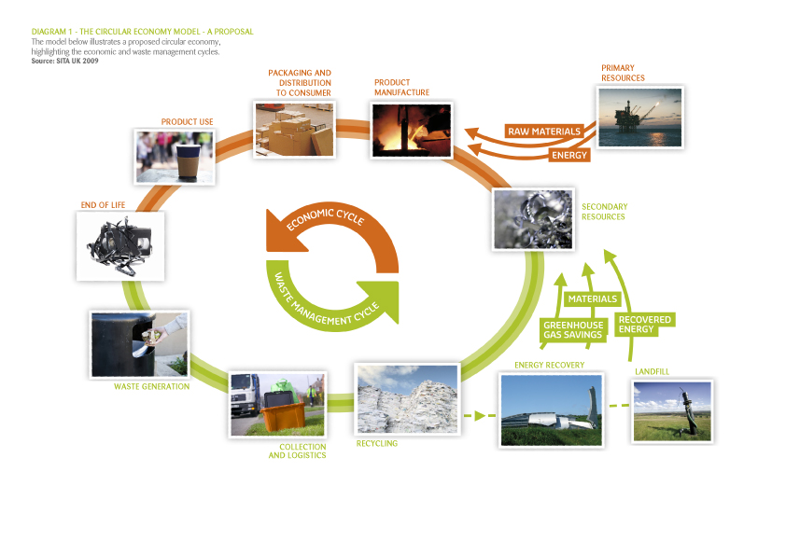

A question that needs to be asked is – is the Circular Economy actually possible and can it be delivered with the current waste management practices?

**The Circular Economic Model – Today**

Diagram 2 is a closer representation of today’s Economic and Waste Management cycles. Notice there is little circularity. The Waste Management cycle is not yet treating waste as a resource because most waste ends up as landfill.

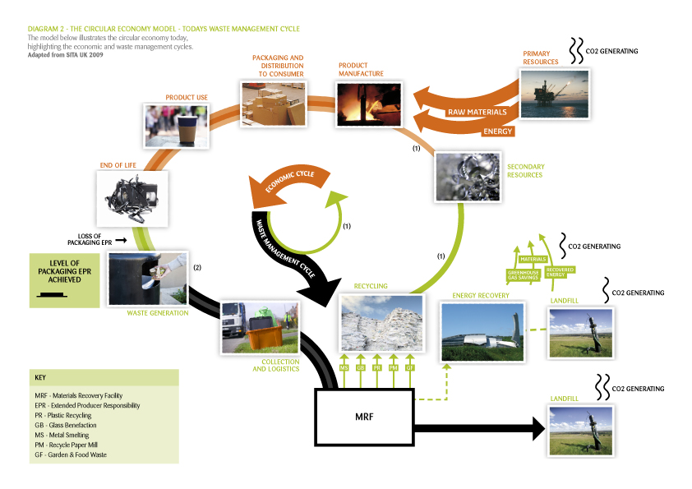

Some important changes in Diagram 2 in comparison to Diagram 1 are:

Change 1 there is a minimal amount of closed-loop recycled material that is currently part of the Circular Economy depicted by the thin green and brown lines. Please refer to (1) on Diagram 2

Change 2 waste is depicted by thick black and grey lines since most waste is dispatched to land fill

Change 3 the Waste Generation point, please refer to (2) on Diagram 2, is where the green used-material becomes black waste material. It is also is also the point of Loss of Packaging EPR. The decision made and action taken at this point is invariably carried out by a human

Change 4 the concept of the Circular Economy could deliver Packaging EPR but actually it is at a very low level in the current Waste Management system

Change 5 a materials recovery facility (MRF), which is at the heart of the current waste management system, has been added. Before the recovered material can be recycled a number of subsidiary plants are required including glass beneficiation, plastics recycling and paper mill plants. These are all highly capital-intensive plants

Change 6 raw materials and energy lines are much thicker compared to Diagram 1 representing Primary Resources predominately supplied from raw and virgin materials not recycled products

**Can an Improved Version of the Current Waste Management System Deliver the Circular Economy?**

In the Circular Economy – Diagrams 1 & 2 show the “Waste Generation” activity. It is performed mostly by a human placing used material in rubbish, trash and recycle bins or crates. These receptacles are located in public places, homes, offices, factories and other workplaces. Immediately after the waste generation activity, the handling and treating of the waste material is taken over by the waste management industry.

The current waste management industry delivers recycling levels from domestic waste at around 50% to 60%. Included in the overall recycling percentages is closed-loop recycling, which is where the recycled material can be re-used to manufacture the same product from which it has come. However closed-loop recycling is at much lower levels than overall recycling levels. Examples of closed-loop recycling are: aluminum containers to over 80% in some regions, steel/tin containers to around 50%, glass containers at approximately 25%, and in the US PET food and beverage containers in the order of 4%.

Closed-loop recycled materials are important because they are already part of the Circular Economy and for the Circular Economy to be a reality closed-loop recycling needs to be at much higher levels.

Non-closed-loop recycling materials represent the majority of recycled waste. These recycled materials are of an inferior quality and hence must find other markets to be re-used in other non-closed-loop ways. Examples include non-color-pure glass cullet from drink bottles being trialed as road base and recycled beverage PET containers being made into synthetic fabrics like carpets.

The SITA UK report on the Circular Economy notes:

***We can only operate effectively in the circular economy if markets can be found for {recycled} products we create.***

Finding markets for recycled materials means either developing completely new markets or displacing existing materials. Developing new markets for low-quality products is not easy and can be lengthy and expensive processes and rather risky as well. Displacing existing materials is not without its problems either. Market requirements and material specifications can change quickly and low quality products are mostly under intense price competition. These are significant difficulties non-closed-loop recycled products must overcome if they are to find a profitable and ongoing market. To date, history is not littered with new and successful market stories for non-closed-loop recycled products.

At 50% to 60% by weight of waste materials recycled the current waste management system clearly is clearly not yet delivering on the Circular Economy. The very low level of closed-looped recycling reconfirms the failure is deep seated. These results, or lack of results, have been achieved after 20 odd years of waste management development. Fantastic advances in recycling and waste treatment processes and technology have resulted. However, the cost has been at least in the hundreds of billions of dollars invested by numerous waste industry parties around the world.

Are there some leading questions to ask? Do the results justify the vast investments to date? Is there a reasonable expectation that the current or even a dramatically improved version of the current waste management practices can deliver recycled material and particularly closed-loop recycled material in satisfactory quality and volume to deliver the Circular Economy?

**The Holy Grail of Waste Management.**

The holy grail of the waste management system is the concept of gaining economies of scale via high volume material throughput at the least cost. The concept stands to reason since waste by definition has very little value if any. Consequently the development of the handling and treatment processes must focus hard to deliver the highest possible throughput at absolute minimum cost.

This profile suggests that for a given amount of material the waste management process should work towards as large as possible and as few as possible receptacles containing as much as possible of any material. The domestic environment with a fixed number of households and therefore receptacles does match this profile. Also the waste comes with its own baggage including pick-up, transport, handling and treatment costs and now for the most part an ever increasing substantial landfill cost. This big negative-value starting point is a serious handicap from which the waste management industry does not recover. The 20 year report card tells us just that despite the waste industry delivering ever more cost effective pick-up services and more efficient material throughputs.

The waste management industry does try genuinely and hard to recover from its handicap. For example, it constructs and operates ever larger, ever more expensive, ever more efficient and much smarter materials recovery facilities (MRFs). The smarter part is designed to recover more and more value from the high-volume throughput. But as the results clearly show, what it recovers does not look anything like the Circular Economy. Is it much closer to a successful One-way Economy – mostly one way all the way to landfill?

Is the Circular Economy a mirage under the holy grail of the waste management industry? It seems like it!

**Can an Alternative to the Holy Grail be Considered so as to Deliver the Circular Economy?**

The holy grail assumes the starting point is waste – mixed materials in a receptacle. Next is delivering the highest-volume lowest-cost throughput. Along the way smart MRFs try hard to squeeze out recycled materials creating value from the throughput. Sadly the value and volume is insufficient for a financially self-sustaining process.

Could a concept be considered that has the retention of the highest material quality and highest value as its primary goal rather than highest-volume lowest-cost throughput?

Quality and value in materials is a direct function of the material purity level. Before each piece of used material is placed in a receptacle with other used materials, the material is just that: “used-material”. It has a high purity. To retain high-purity and “used-material” status a place, location or bay for each different material must be made available. For purity optimization a place, location or bay on its own is not enough when humans are doing the placing. Each dedicated material place, location or bay must be machine checked for the correct material guaranteeing the purity of the material in each place, location or bay.

This general concept is not new to the waste management industry. It is called “pre-sort” or “source separation” and it has been tried by the waste management industry in many guises and formats in different regions and countries, though mostly unsuccessfully. “Pre-sort” or “source separation” systems have relied on human decision making alone at the point of placement of material into a receptacle which provides no material purity guarantees. On the other hand the “used-material” concept demands material placement is machine checked. Herein is a clear difference between the waste industry’s “pre-sort” or “source separation” attempts and the “used-material” concept.

The “used-material” concept starts from guaranteed purity, then processes the pure material to a high quality high value closed-loop recycled material. If the concept can deliver quantity as well as quality and value, then the vision of the Circular Economy is coming into much clearer focus. However, a simple conceptual description is one thing. How would it look and actually be delivered in the real world?

**In Reality What Would the Used-Material System Look Like?**

The Used-Material System calls for dedicated material places, locations or bays to place used-materials which are then machine checked for the correct material. How can this system be delivered practically?

Material identification sensors (MIS) exist mostly due to the technology developing activities of the waste industry and therefore identifying materials is not a problem. However the requirement of a number of different material-dedicated bays each with a dedicated MIS for that material is suggesting a new piece of equipment.

The generic piece of equipment is called an UMPRUN - an acronym for **U**sed **M**aterial **PR**ocessing **UN**it. For the household or office the UMPRUN application is called a **Recyclertron©.** In fact a **Recyclertron©** is a new household appliance.

Material identification is only one requirement before used material can be processed to a closed-loop manufacturing input. Taking the example of household food and beverage containers as the used-materials, other processes incorporated into a **Recyclertron©** include washing, drying, grinding, granulating and compacting before the products are separately stored in a detachable Product Storage Unit (PSU). And as with the current household waste and recycling system, a custom-built bulk transport vehicle picks up and empties the contents of the PSU for transport to a bulk transfer and distribution station. From here the closed-loop products would enter the manufacturing processes.

For the **Recyclertron©** to deliver the Circular Economy on its coverage of food and beverage containers **Recyclertron©s** must be purchased or used by large numbers of householders. This is a very big ask. It also raises a number of very valid questions. The biggest is – “Why would a householder spend their hard earned cash on a **Recyclertron©?”**. And even if there are good reasons, will householders actually purchase **Recyclertron©s**?

**Why would a householder spend their hard earned cash on a Recyclertron©?**

In return for an appliance’s purchase price householders receive benefits. These are mostly related to enhanced convenience. A refrigerator provides a neat and tidy place to store food and drinks and is a convenient way to keep drinks cold on demand. Because it preserves food and drinks the amount wasted is decreased thereby providing a saving on the repurchase cost of perished foods and drinks. Its ability to preserve the usable life of many foods and drinks means that larger amounts can be purchased at a single time reducing the frequency of visits to the shops. In addition to the appliance purchase price the running cost includes a comparatively large electricity bill and a low maintenance cost.

In return for the **Recyclertron©s** purchase price the household receives an odorless, clean and tidy place for recycled food and beverage containers. Depending on the volume of recycled products generated by a household, the detachable PSU containing the recycled products will need to be put down to the curbside between 3 and 8 times a year. The current recycle bin or crate is normally put out to the curb fortnightly or weekly being 26 or 52 times a year respectively. Partially off-setting this six-fold time saving, a **Recyclertron©** will take marginally longer to load and operate than just tossing used containers into the recycle bin or crate. In addition to the purchase price, the **Recyclertron©** will necessitate a relative minor electricity bill and a small washing detergent cost. The maintenance of the **Recyclertron©,** due to its moving and wearing parts, is expected to be higher compared to a refrigerator.

Because closed-loop recycled products generated by the **Recyclertron©** are valuable the householder will receive cash payments - a unique benefit and a world first for any household appliance.

Containers manufactured from recycled products require substantially less energy to produce compared to the containers manufactured from virgin materials. In addition to the energy saving is a consequential reduction in CO2 emissions. The net energy saving and reduced CO2 emissions gained from operating a **Recyclertron©** delivers an environmental benefit and therefore a “feel good” emotion to the householder in the knowledge that he or she is doing the right thing for the planet. The “feel good” emotion will be reinforced by the receipt of carbon credits in those regions where there is a price on carbon. Purchasing a **Recyclertron©** is similar to purchasing a small plot of land to grow trees. Operating a **Recyclertron©** is equivalent to planting trees in the plot.

On first look, in comparison to refrigerators, **Recyclertron©s** stack up. Clearly it is very early days. The purchase price and the level of payment to householders as a result of the **Recyclertron©** products will play an important role. However, it should be noted that refrigerators have achieved in excess of 99% market penetration into western households.

**The Loss of Material Value and Loss of the Possibility for Packaging EPR**

The current waste generation activity immediately transforms used-material to waste material. Consequently and critically, used-material value is lost or at best dramatically reduced.

Packaging extended producer responsibility or packaging EPR for food and beverage containers is the responsibility of producers (brand owners) primarily and, to a lesser extent, retailers of the products. For many reasons it is generally accepted by the public, producers, retailers and law makers that EPR is a worthwhile goal. At the waste generation activity or point, the potential to regain packaging EPR is compromised and the opportunity for most packaging EPR is lost.

**Why Is the Product Value Lost?**

Once materials are put together and waste is created, the cost of separating them to a purity that has real financial value has proved very difficult. Take PET plastics as an example. After the household recycle bin contents are emptied and transported to a materials recovery facility (MRF) PET plastic containers are crushed into bales. Then the bales are transported to a plastics recycling plant. In these capital-intensive plants, due to the material contamination in the PET bale, approximately 30 different processes, some of which are technically ingenious, are required to produce recyclable PET. And even then the resultant PET flakes are most likely not food and beverage quality. This quality is needed to create the high-value and high-purity product suitable as inputs to the PET beverage container manufacturing process. In the US approximately 4% of used PET plastic containers are recycled into new PET containers. Clearly the current Waste Management system has real difficulty generating closed-loop recycling PET plastic containers.

Glass containers in the collection and recycling process create another problem, especially the broken ones. Mixed colored bottles and broken glass from a MRF need to be transported to a capital-intensive beneficiation plant. Despite fantastic technology in the beneficiation plants, broken bottles causing cross-contamination of colors makes glass extremely difficult to separate into pure colors. And color-pure cullet is required as an input to re-melt glass furnaces if closed-loop glass recycling is to occur. Because of the technically difficulty and low glass cullet value, there is limited incentive to produce large volumes of color-pure cullet. Re-melt glass furnaces can take 90% of their charge as closed-loop cullet. Somewhere in the order of 25% of the furnace charge is cullet because that is the amount of color-pure cullet created by the current Waste Management Cycle.

The concept of energy from waste sounds fantastic. However there are drawbacks. Purifying the waste material to be suitable for combustion is costly. All the waste material must be checked for toxic contaminants and where present the contaminants must be removed. If not removed the toxic flue gases must be scrubbed and the resultant toxic liquid must be disposed of. The residual burnt material is also a waste to be disposed of. Burning waste materials to produce energy generates CO2 just as burning coal or paper or wood does. Generating energy from low calorific value mixed waste materials produces very much less energy than the energy required to generate the material in the first place from virgin inputs. And if the Waste Management system was efficient in separating out the valuable combustible material in the first place, the calorific value of the waste material would approach zero.

Simply the current Waste Management Cycle including energy-from-waste does not and will not in the future create sufficient financial value to be financially or environmentally sustainable. Further the system mostly does not generate product to a specification to match virgin material. Hence new markets for the current recycled materials must be developed which is a risky and costly exercise. Government subsidies and/or regulations will always be required to keep the existing Waste Management Cycle operating.

An alternate dramatically improved financially and environmentally sustainable system is required to deliver a workable Circular Economy and at the same time deliver packaging EPR.

**The Alternative: Used-Material Management Cycle with UMPRUN/ Recyclertron©**

Used-material purity must be guaranteed and a given. Purity delivers value and is the starting point to deliver closed-loop high-value, virgin-material equivalents to existing market specifications. The Used-Material Capture Point is before the waste-generation or material mixing point. Diagram 3 below shows the Used-Material Capture Point.

Material purity guarantees cannot be left to voluntary human decision making and action alone. Hence a used-material management cycle must start with a dedicated position for each material which is sensor identified. Such a requirement is calling for a clever piece of equipment, positioned at the Used-Material Capture Point which is either a machine in a factory, hospital or building site or an appliance in a home or office. The machine or appliance will be positioned at the site where the materials become used-materials.

With guaranteed material purity assured, the next step is for each material to be processed so as to achieve a product specification for an existing market: cleaned, ground, flaked or crushed material to a specification – meeting the input specifications of each current manufacturing process respectively. The now closed-loop recycled product must be separately stored ready for collection. Again a machine or appliance is being called for. Further smart equipment is required to measure the amount of each valuable product separately before dispatch. For dispatch and transportation the products must remain separate.

**The Circular Economic Model – With Used-Material Management Cycle**

Diagram 4 on the next page graphically depicts the Used-Material Management Cycle when UMPRUNs and **Recyclertron©s** are added. Note that the Used–Material Management Cycle is diagrammatically placed in the Economic Cycle. It is done so here purely to highlight that the Used–Material Management Cycle generates value.

The Level of Packaging EPR Achieved graph shows a substantial increase in the Packaging EPR delivered.

Not all material can be considered used-material to be recycled. Hence, a simplified waste management stream will be needed for a reduced volume of material which will be directed to landfill.

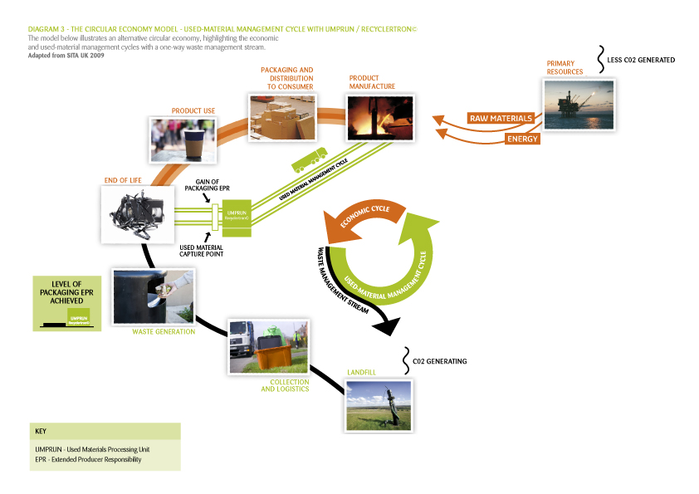

Notice also that the Energy from Waste Recover process has been removed. The Used-Material Management cycle retains the total energy value of the combustible material by returning products into closed-loop recycling processes. If instead the material was directed to an Energy from Waste Recover process, the energy value recovered would be less than 40% of that retained in the Used-Material Management Cycle. In the Energy from Waste Recover process, even if one can assume there are no toxic materials in the material being combusted, CO2 is generated. It must be captured and as with the solid residual burnt waste created both the CO2 gas and solid wastes must be disposed of safely.

Importantly there is a dramatic reduction in requirement for raw materials and energy from primary resources as inputs to Product Manufacture represented in Diagram 3 as thin lines compared to the much thicker ones in Diagram 2. The difference is supplied by the closed-loop recycled products generated by the Used-Material Management Cycle.

Diagram 4 below depicts an achievable Circular Economy which transforms used-material into valuable resources and delivers Packaging EPR.

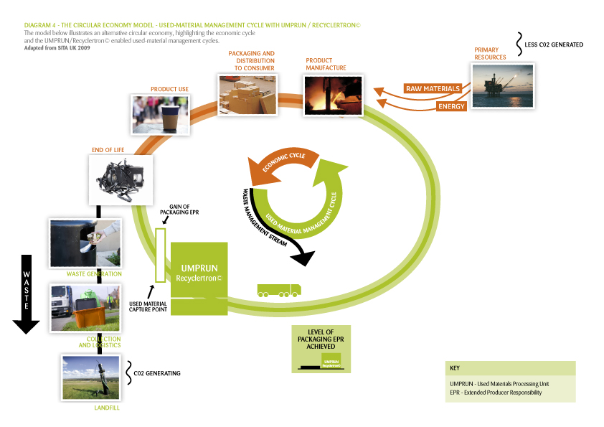

**Value Retention and Creation and Regaining Packaging EPR**

The Used-Material Management Cycle retains raw material value and processes the material to create higher value. For example, the current recycled baled PET food and beverage container produced by an MRF have at best a value one third per pound (or per kilo) price of virgin PET pellets used to manufacture a food and beverage PET container. PET flakes produced by a **Recyclertron©** will have specifications as near as possible to virgin PET pellets, thereby justifying a near equivalent price. However, in any future carbon restricted economy virgin PET pelletswill be supplied with carbon costs and **Recyclertron©** PET flakes will come with carbon credits. Potentially, depending on the level of the carbon price, **Recyclertron©** PET flakes will command a higher price than virgin PET pellets.

Delivering packaging EPR for food and beverage containers under the current Waste Management system is just not possible. There is not enough suitable recycled material generated by the system. And of the amount generated all but a small percentage is not of sufficient quality. Once packaging material enters the current Waste Management system packaging EPR for that packaging is lost. With the Used-Material Management system incorporating UMPRUNs and **Recyclertron©s** each piece of used material that finds its way into the system will be 100% closed-loop recycled. Packaging EPR for this used packaging is clearly regained.

**A New Machine or Appliance Requires Human Behavioral Change! Will it Occur?**

The value creation of the Used-Material Management Cycle which incorporates UMPRUNs and **Recyclertron©s** will generate financial incentives and deliver other benefits to the user to facilitate must needed human behavioral changes. Over and above cash payments, the **Recyclertron©,** being a household appliance, will also deliver significant convenience benefits to householders. And convenience benefits are the primary reason that household appliances are purchased.

Clearly recycling is considered a social good by much of the public in many countries. Currently, what is called recycling in the household context and what the public mostly understands to be a recycling system is in fact firstly and primarily a ***waste collection system*** with some recycling and minimal closed-loop recycling. In all likelihood a **Recyclertron©** household, incentivized by convenience benefits and cash payments, will closed-loop recycle to levels close to 100% thereby providing householders with their first real opportunity to be excellent and responsible recycling citizens and justifiably feel good with themselves.

**Used-Material Management Cycle with Recyclertron© delivers Packaging EPR at a Profit?**

The Used-Material Management Cycle incorporating **Recyclertron©s** in households provides an opportunity for producers (brand owners) and retailers to deliver packaging EPR for their food and beverage containers at either a small cost or potentially even at a profit.

**Delivering the Circular Economy and Packaging EPR – Next Step.**

The Circular Economy and Packaging EPR will be delivered by the implementation of the Used-Material Management Cycle which requires commercially-ready **Recyclertron©s** to be available for households to purchase as soon as possible. Implementation can occur immediately after the four year and four stage **Recyclertron©** commercialization project.

The commercialization of a **Recyclertron©** needs existing waste industry equipment and processes to be simplified and made smaller. Fortuitously the waste industry has already commercialized and operated over many years wash cycles, material identification sensors, grinders, granulators and compactors for large commercial applications. Simpler, lighter, smaller and cheaper versions of these components need to be re-engineered to more specific though very much less robust specifications suitable for mass production. Re-engineering will be performed in the first commercialization stage called Prototype Design.

The successful completion of the Prototype Design stage will signal the commencement of a parallel commercialization of custom UMPRUNs for commercial, industrial, construction and demolition industry applications.

Successful commercialization of **Recyclertron©s** and UMPRUNs will deliver the Circular Economy and packaging EPR at a rate commensurate with the market penetration achieved.

**Funded by Those Who Have Gained the Benefits! – Isn’t That the Way it Should Be?**

Compared to the 20 year and hundreds of billions of dollar development funds consumed by the current waste management system to deliver a lack-lustre and unsatisfactory outcome, the proposed implementation of the Used-Material Management Cycle will require minimal funding - in the millions not billions of dollars. Once the re-engineering and commercialization stages are completed at an estimated cost of US$10 million and a duration of 4 years, the market implementation and operation of **Recyclertron©s** and UMPRUNs will be self-funded by the very people who have gained the benefits from the use of the material they no longer use, need or want – ie, consumers, factory owners, producers (brand owners), retailers, other businesses and organizations. And isn’t that the way it should be?

The beneficiaries of the Used-Material Management System will be the same consumers, factory owners, producers (brand owners), retailers, other businesses and organizations – and probably even more importantly – the planet and future generations.

Funds are needed now by Umprun Pty Limited to complete the UMPRUN/**Recyclertron©** commercialization project

Can Packaging EPR Be Made Profitable for Brand Owners and Retailers?

**Definitions and Abbreviations**

In this document **Extended Producer Responsibility** is referred to as **EPR** and **Producer Responsibility Recycling** is referred to as **PRR**. Definitions are given at the end of the document.

**Food and Beverage Containers** are referredto as **F&BCs.**

References to EPR & PRR in this document mean EPR & PRR for F&BCs.

Recycling in this document refers to recycling of F&BCs.

**EPR & PRR for Food and Beverage Containers (F&BC)**

EPR & PRR for F&BCs is the responsibility of producers (brand owners) primarily and, to a lesser extent, retailers of the products. For many reasons it is generally accepted by the public, producers, retailers and law makers that EPR & PRR is a worthwhile goal. However there is not a current practical and financially sustainable solution to deliver EPR & PRR for F&BCs anywhere in the world – let alone a profitable one.

In the context of F&BCs, EPR & PRR is delivered when it can be verified that F&BC container material is re-used in some form and does not find its way into landfill. EPR & PRR verification can be in the form of tracking the container material or purchasing an equivalent amount of equivalent recycled material. Understandably tracking containers is not practically feasible. Purchasing an equivalent amount of equivalent recycled material by all producers is also not currently possible as there is at best a material short fall of 50% and at worst 96%.

So here currently is the real dilemma for producers (brand owners) and retailers - a desire to deliver EPR & PRR and no effective solution to deliver it. This situation is unlikely to change in the foreseeable future and definitely not by 2020 even assuming the very best advances in the business as usual processes.

Should producers (brand owners) and retailers be required by law or consumer sentiment or voluntarily, as some have decided to do, to deliver EPR & PRR for their F&BC footprints there are existing methods though the costs will be substantial.

**Existing Methods for Producers and Retailers to Deliver EPR & PRR for F&BCs**

The obvious existing method is for producers (brand owners) and retailers to subsidize the current domestic recycling system to whatever amount is required to produce enough recycled product. At current estimates the cost would be prohibitive threatening the viability of the producers (brand owners) and possibly the retailers as well.

Efforts to reduce material content in each container have been successful. However, the required increased material strength delivered at a sensible cost has clear physical and manufacturing limitations. Changing the packaging material to one more identifiable and recoverable in the current recycling systems, for example replace glass or PET containers with aluminum, is not taking on. Whilst adding biological materials to plastics is a very promising development, still there remain physical limitations and still the container must be recovered. All these valuable and worthwhile activities come at very significant research and development risk and cost to produce an outcome at the margin.

Changing the habits of households at the point of the household waste bin to voluntarily assist in the current recycling effort has proven it is doable at a cost. The education process by information delivery has now been in place for decades and the potential for improved outcomes is diminishing. A variation on the current recycling system are new recycling kiosks at supermarkets which deliver coupon style incentives and enhanced convenience by being placed where householders do their shopping. However, the householder carries out this activity at a convenience cost by way of the requirement for an extra container at home and transporting the container to the kiosk and loading it up. The overarching limitation of any of the current systems is the existing domestic recycling system’s inability to deliver valuable recycled products.

**Identifying Point of Loss of Control for F&BC EPR & PRR**

While the producers (brand owners) have the greatest control over product design and marketing, clearly after a product is purchased in a retail outlet the F&BC leaves the retailer and both the producer (brand owner) and retailer lose control before the F&BC’s end-of-life. This loss of control makes EPR and PRR delivery extremely difficult and expensive.

**Existing Recycling Systems Chance of Regaining EPR & PRR Control?**

From the loss of control point most F&BCs, in the order of 70%, find their way into households, therefore it is in households where control of the end-of-life of F&BCs needs to be regained.

Despite huge investments over twenty odd years by local governments, producers (brand owner), retailers and the domestic waste service industry well supported by a sympathetic public, the low recycling levels of the current domestic recycling systems confirm the inability of producer (brand owner) and retailer to regain control of the end-of-life of their F&BCs.

Many recycling systems have been and are being tried – separate recycle bins, bottle deposit systems, community involvement, Terracycle and RecycleBank are amongst the better known ones. While some systems obtain improved levels of collection, the level of reuse remains stubbornly low. Independent of which system has been tried, the level of closed-loop-recycling is extremely low.

By any reasonable assessment, the current systems have no chance of regaining EPR & PRR control of F&BCs for brand owners and retailers.

**The Reason for the Failure of EPR & PRR for F&BC**

Around the world, people have demonstrated their commitment to recycling by diligently separating their waste into defined recyclable elements of paper, glass, plastics and metal. Incredibly, they have done this with typically no greater incentive than to preserve the environment and sustain the planet. Around the world, local councils have supported and promoted the concept by providing householders and communities with the systematic collection of materials for recycling.

However, despite decades long genuine efforts by government authorities, together with the existing pick-up services, material recovery facilities and recycling plants, insufficient marketable and valuable products are generated to even partially pay for the processing costs. Hence, the majority of all F&BCs diligently collected by the public and genuinely processed by the domestic waste and recycling industry still end up in landfill because the end-products do not have enough value.

So the root cause of the failure of EPR & PRR when it comes to F&BCs is that the current system does not generate anywhere near sufficient end-of-life product value. And in spite of the billions of dollars from governments and private industry around the world having been invested in improving the processing over a twenty year period, the end-of-life value creating problem remains intractable for as far as the eye can see.

**At What Exact Household Activity Point Does EPR & PRR for F&BCs Fail?**

The value of materials is primarily dependent on the quality or purity of the material and whether a market exists for the material. This applies to gold, copper, flour etc and of course recycled products.

F&BCs are manufactured from valuable raw materials. For example, PET is manufactured from ethylene, a petroleum refinery product, and aluminum requires a lot of electricity. Each individual used-F&BC retains this raw material value and more. However, once materials are mixed, as occurs for example when a PET and aluminum F&BC is placed in the one bin or crate, instantaneously the material value of the container is lost and significant additional processing and handling costs are added and mostly the resultant products are not suitable for an existing market. It is at this very “material mixing” and “instantaneous loss of value” household activity point that the producer (brand owner) and retailer currently lose any chance of regaining control of the F&BC’s end-of-life and as a consequence it has failed in its EPR & PRR.

If the producer (brand owner) and retailer could influence the human behavior at this “material mixing” and “instantaneous loss of value” household activity point, by regaining end-of-life control of the F&BCs then they will deliver EPR & PRR.

**Regaining End-Of-Life Control of F&BCs – Enter the Recyclertron©**

Household appliances, for example refrigerators, washing machines, clothes dryers etc, have been purchased by nearly all first-world households. When the purchase was made for the first time, that household changed its human behavior at a particular activity point. In return for the purchase price and the changed behavior the household received desired benefits, mostly related to enhanced convenience of some nature.

The **Recyclertron©** when purchased by a household will change that household’s F&BC behavior before the critical “material mixing” and “instantaneous loss of value” point and therefore ensure pure materials retain their high inherent raw material value. This human-behavior change will also deliver desirable benefits to the householder. Convenient, tidier, reduced odor and increased hygiene are benefits. At the same time a householder gains a feel-good emotion since the householder is actually contributing to society’s social good.

For the very first time in household appliance history, the **Recyclertron©** will ensure cash payments to householders for their recycling effort thereby delivering a unique and world-first additional benefit.

For producers (brand owners) and retailers the changed household behavior, made possible by a **Recyclertron©,** provides an effective solution to regain end-of-life control of their EPR & PRR for F&BCs.

**How is Profitable Packaging EPR Delivered?**

The producer’s or retail company’s EPR is delivered by that company purchasing the **Recyclertron©** product. As a result EPR is obtained without recourse to or relying on the EPR-flawed domestic waste recycling system currently delivered by cities or private waste service contractors.

Purchase of the **Recyclertron©** products by the brand owner or retail EPR company will be at bulk supply prices allowing direct on-selling to the packaging manufacturer potentially with a margin. Packaging EPR is therefore delivered to the brand owner or retail EPR company at no cost and potentially a profit. Note that the brand owner or retail EPR company does not need to take physical delivery of the **Recyclertron©** recycled product to achieve its packaging EPR.

**Regaining Control - The Cost to Producers (Brand Owners) and Retailers.**

To regain end-of-life control of F&BC’s in a household, producers (brand owners) and retailers need to ensure a household has the opportunity to purchase a **Recyclertron©.** The first step in delivering that opportunity is to ensure the commercialization process of the **Recyclertron©** domestic recycling appliance starts and Stages 1 & 2 are completed.

The **Recyclertron©** commercialization project is at the prototype design stage. The complete project will include four commercialization stages taking approximately 49 months and US$10 million in commercialization funds. Prototype Design is Stage One (1) of the four stages and will cost US$1.0 million. Stage 2 is the construction of the prototype and will cost US$400K.

With the successful completion of Stages 1 and 2, if so desired by producers (brand owners) and retailers, no further funding for the following two Stages will be needed since the project will be at a stage where the normal equity and loan markets will step in and provide the remaining commercialization funding. With the successful completion of Stages 1 & 2, there is every likelihood that an international household appliance manufacturer will provide a significant portion of equity funds that will be needed to complete Stages 3 & 4.

Completion of Stage 4 will indicate the commencement of the first full-roll-out of **Recyclertron©s** into households and the commencement of producers (brand owners) and retailers delivering EPR and PRR for F&BCs.

**Definitions**

**Extended Producer Responsibility (EPR)** is a strategy designed to promote the integration of environmental costs associated with goods throughout their life cycles into the market price of the products. EPR is the extension of the responsibility of producers, and all entities involved in the product chain, to reduce the cradle-to-cradle impacts of a product and its packaging; the primary responsibility lies with the producer, or brand owner, who makes design and marketing decisions. EPR – also known as Product Stewardship – is a policy approach that holds producers liable for the costs of responsibly managing their products at end of life. Extending producer responsibility for products from “cradle to cradle” acknowledges that producers (usually brand owners) have the greatest control over product design and marketing and therefore have the greatest ability and responsibility to reduce toxicity and waste.

**Producer Responsibility Recycling (PRR)** is the means for achieving a deep transformation of wasteful production and consumption. The aim is for a transition from traditional end-of-pipe waste "diversion" programs provided by local governments to "cradle to cradle" recycling systems designed, financed and managed by producers, in order to drive improvements in product design, stimulate local economies and reduce climate change impacts of transportation- and energy-intensive product chains.

UMPRUN- **Recyclertron™** delivers Packaging EPR

**What is UMPRUN- Recyclertron™?**

UMPRUN is a generic name for a new recycling appliance for the household and office or a recycling machine for the factory, hospital, restaurant or building site.

UMPRUN is an acronym for **U**sed **M**aterial **PR**ocessing **UN**it. **Recyclertron™** is the current brand name for the household or office recycling appliance application of an UMPRUN.

**Recyclertron™ Delivers Packaging EPR for Branded Consumer Products?**

In the household or office a **Recyclertron™** delivers packaging **EPR** to companies whose branded consumer products are packaged in plastics, glass and metals and to retailers who market the branded products to consumers.

**UMPRUNs Also Delivers Packaging EPR?**

UMPRUN’s for non-domestic applications like factories, hospitals, restaurants and building sites will also deliver packaging EPR for companies that supply branded non-consumer products as inputs to manufacturing and other processes. The packaging that comes with the inputs will be processed by custom-designed UMPRUNs to closed-loop recycled products.

An example is the large plastic bags in which beef and pork carcass parts are delivered to small goods factories. Custom-designed UMPRUNs for non-domestic applications will process used items like syringes, the packaging they come in and medicine bottles in hospitals to closed-loop recycled products delivering packaging EPR for the suppliers of the syringes and medicine bottles.

However, in comparison to branded consumer products like food and beverage containers there is a very much reduced public exposure of non-consumer used packaging and products. Consequentially, there is a reduced level of societal pressure and resulting in less EPR incentive for individual suppliers to deliver their EPR.

In summary, from a packaging EPR perspective, commercializing the **Recyclertron™** has a higher priority than UMPRUN’s for non-domestic applications.

**How Does Recyclertron™ Deliver Packaging EPR for Branded Consumer Products?**

A household which purchases a **Recyclertron™** will recycle its plastics, glass and metal packaging to pure and valuable products which are suitable for direct close-loop ingress into the packaging manufacturing process. For example, PET food and beverage containers (F&BCs) will be processed by the **Recyclertron™** to F&BC quality PET flakes and these flakes will be equivalent to virgin PET materials used in F&BC manufacturing.

The product brand owner or retail company’s EPR is delivered by the company purchasing **Recyclertron™** close-looprecycled product. As a result EPR is delivered by the brand owner or retail company for the recycled product for each home with a **Recyclertron™** installed.

Purchasing of the **Recyclertron™** products by the brand owner or retail company will be at bulk supply prices allowing direct on-selling to the packaging manufacturer potentially with a margin. Packaging EPR is therefore delivered to the brand owner or retail EPR company at no cost or potentially a profit. Note that the brand owner or retail EPR company does not need to take physical delivery of the recycled product to achieve its packaging EPR.

Hence product brand owners or retail companys who wish to deliver packaging EPR now have a straight forward and potentially profitable way to do so by influencing households to purchase and operate **Recyclertron™s.** The first step is to assist in the commercialization of the **Recyclertron™.**

**Status of the UMPRUN and Recyclertron™ Commercialization**

To commence the commercialization process for a **Recyclertron™** appliance and UMPRUN machine for non-household applications re-engineering is required of four currently operating commercial pieces of equipment to produce components that will fit into the appliance or machine. This first stage is called the Prototype Design.

It is estimated that approximately US$700K is required for the equipment re-engineering part of the project and US$300K is required to design and engineer the components into an appliance. Together the Prototype Design project is estimated to take 18 months to complete.

The Prototype Design Stage is the first of a four (4) stage commercialisation plan to have a consumer **Recyclertron™** recycling appliance ready for purchase by consumers in home appliance retail stores within four (4) years.

Successful completion of the equipment re-engineering part of the Prototype Design Stage will allow the concurrent commencement of commercialisation of UMPRUN’s for non-domestic applications like factories, hospitals, restaurants and building sites.

**The Recyclertron™ Commercialization Plan**

The commercialization of a **Recyclertron™** is planned to be carried out by Umprun Pty Limited (UPL) in collaboration with brand owner or retail packaging EPR-seeking partner companies in Four Stages and is estimated to take four years and require total funding of an estimated US$10.0 million. The four Commercialization Stages are;

1. **Prototype Design** – Estimated cost US$1.0 million, duration 18 months.
2. **Prototype Manufacture** – Estimated cost US$400,000, duration 9 months.
3. **Prototype Testing, Redesign and Re-Manufacture** – duration 12 months.
4. **Small Scale Community Trial Implementation** – duration 10 months.

The commencement of the First Full-Scale Roll-Out of **Recyclertron™s** into a selected urban area designates the completion of the four staged commercialization plan.

**Funding for the Recyclertron™ Commercialization Plan**

Part funding of US$1.0 million First Stage Prototype Design to the tune of US$500K is currently being sought by UPL from brand owner or retail packaging EPR-seeking partner companies. UPL will fund the remaining US$500K from shareholders and investors associated with UPL.

In return for the US$500K funding, UPL will offer the brand owner or retail packaging EPR-seeking partner company a First Staged Option for the eventual rights to purchase **Recyclertron™** products at market prices for a limited number of defined urban areas.

So the funding sought is to directly assist suppliers with delivering their packaging EPR.

**Commercialization of UMPRUNs for Non-Domestic Applications**

Completion of Stage 1 of the **Recyclertron™** will be a precursor to the commercialization of UMPRUNs for non-domestic applications.

UMPRUNs for non-domestic applications in factories will require a custom commercialization project for a number of factories in different industries to show that an UMPRUN can be commercialized for any number of industries. UMPRUN’s are applicable to factories wherever process inputs are delivered in different packaging materials. An example of such an industry is the processed meats industry where different meat inputs, eg. beef & pork, are delivered in packaging of different, though mostly plastic, materials. The packaging can be biologically contaminated when blood from meat is on the packaging raising bio-security and quarantine issues. As the amount of plastic packaging can run well into the thousands of tons per annum, producing UMPRUN high value pure recyclable products can potentially turn around a highly expensive waste packaging removal cost to a significant profit after the cost of the custom UMPRUN machine commercialization.

Similar comments apply to UMPRUN commercialization projects for hospitals and building sites. Restaurants on the other hand do not have the same volume of recyclables as factories, hospitals and building sites. In restaurants the most numerous containers to recycle by a long way are glass wine bottles. Recycled glass cullet has the lowest recycle product value of the major recyclable F&BC materials making an UMPRUN for restaurants probably the least commercially viable of the non-domestic UMPRUN applications.

**Reduced EPR for Non-Domestic Applications**

EPR exists for companies delivering branded products as inputs to other processes. However, due to the much lower public exposure such products tend to bring a lower level of EPR particularly when compared to the plastic beverage containers sold in super market retail outlets.

On the other hand, in non-domestic applications the volume of mixed plastics packaging resulting from packaged inputs will justify the commercialization of a custom UMPRUN machine for each industry application. However, removing the commercialization risk for the machine components is required, and that will be delivered by Stage 1 of the **Recyclertron™** commercialization plan.